IOTCEDPP evaluation via Postman

Testing the IOTCEDPP Application via Postman
The “DPP IoT Digital Twin Device Simulator” Postman collection comprises two tests: Step 1 – GET DPP IoT REST API and Step 2 – POST IoT Sensor Data.
The collection-level variables are id, operator_uoi, capture_url, and qr_url, where id denotes the Unique Product Identifier (UPI). A predefined ID value is required to simulate a prior QR code scan.

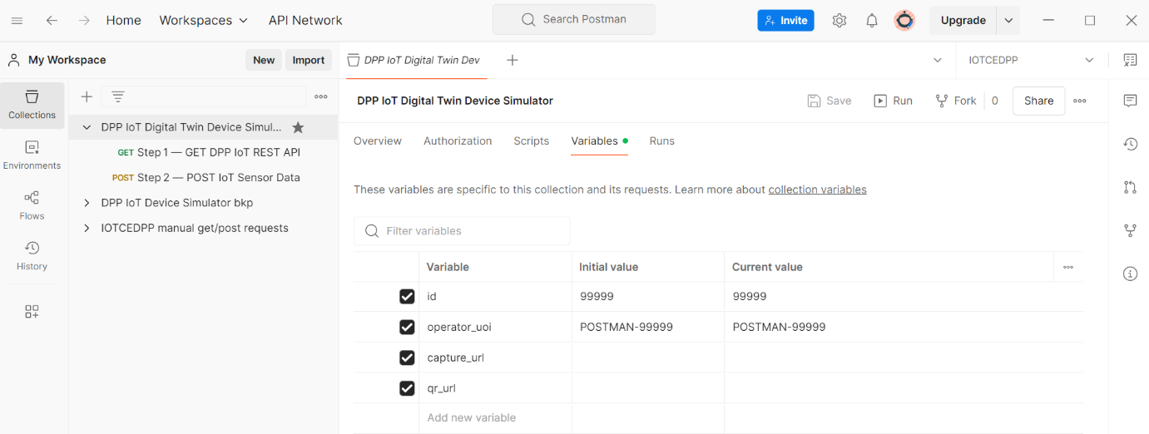

Step 1 — GET DPP IoT REST API
The first test performs a GET request to the DPP IoT web service endpoint (/iot/) as discovered via the public DPP page, using the specific HTTP Accept header application/vnd.iotcedpp.capture+json.
This request triggers an HTTP redirect, from which either the Location header is retrieved or the service URL is extracted from the JSON response.

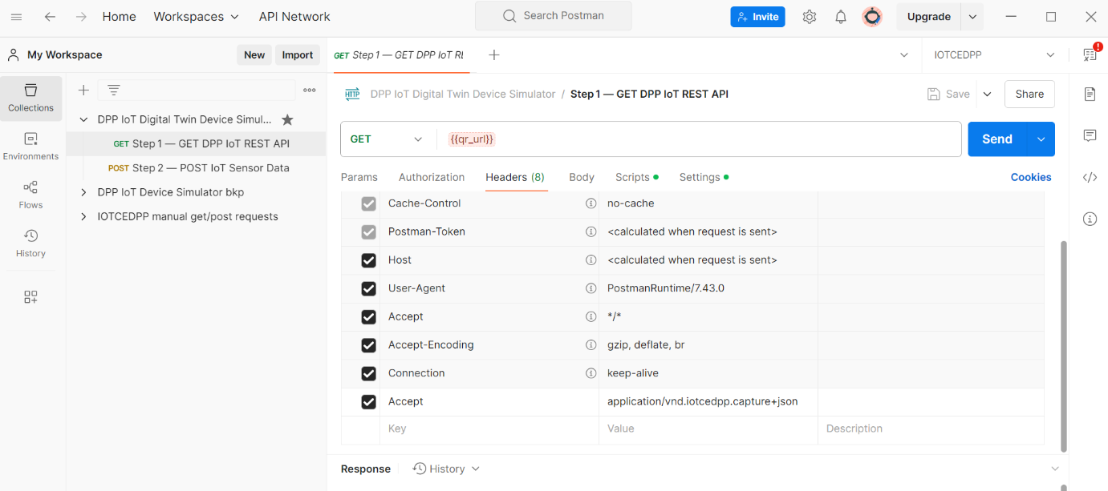

This test implements the following JavaScript logic:
Pre-request script – executed before the request is sent. It can be used to construct API workflows by dynamically configuring request parameters.

// --- Build QR URL dynamically -------------------------------
const id = pm.collectionVariables.get('id');
const qr = `https://apex.oracle.com/pls/apex/r/iotcedpp/` +
`iotcedpp-app/dpp?ID=${id}`;
pm.collectionVariables.set('qr_url', qr);
Post-request script – executed after the response is received. It is used to implement assertions (tests) and to configure a response visualizer.

// --- Derive capture_url -------------------------------------
const loc = pm.response.headers.get('location');
let url = loc || '';
if (!url) {
try {
const body = pm.response.json();
url = body.links && body.links[0] && body.links[0].href || '';
} catch(e) { /* no JSON */ }
}
if (!url) {
url=`https://apex.oracle.com/pls/apex/iotcedpp/iot/${pm.collectionVariables.get('id')}`;
}
pm.collectionVariables.set('capture_url', url);
console.log('capture_url =', url);
Accordingly, the test can either capture the HTTP Location header or extract the endpoint URL from the returned JSON object, depending on whether the following Postman option has been enabled in advance: “Automatically follow redirects — Follow HTTP 3xx responses as redirects”.

Step 2 – POST IoT Sensor Data
The second test transmits (POST) sensor data via the IoT web service to the product-specific DPP endpoint. The IoT payload is generated randomly and represents synthetic telemetry data.

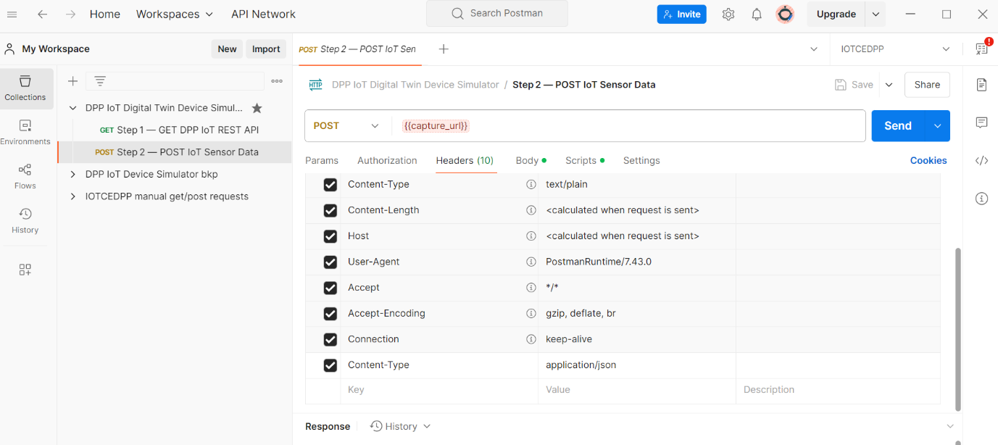

This test implements the following JavaScript logic:

Pre-request script – executed before the request is sent, enabling dynamic construction of the request (e.g. generating telemetry values).

// --- Random sensor data ---------------------------------------------------
function rnd(min, max){return Math.floor(Math.random()*(max-min+1))+min;}
function pick(arr){return arr[rnd(0, arr.length-1)];}
const TYPES = ['location','condition','availability','usage'];
const sensor_type = pick(TYPES);
let sensor_value;
// -------- location --------------------------------------------------------
if (sensor_type === 'location') {
const lat = (rnd(-9000, 9000)/100).toFixed(4); // -90.00 … +90.00
const lon = (rnd(-18000,18000)/100).toFixed(4); // -180.00 … +180.00
sensor_value = `Lat:${lat},Lon:${lon}`;
// -------- condition -------------------------------------------------------
} else if (sensor_type === 'condition') {
sensor_value = pick([
`Battery ${rnd(10,100)}%`,
`Temp ${rnd(-10,80)}°C`,
`Humidity ${rnd(20,95)}%`,
`Pressure ${rnd(90,110)}kPa`,
`Vibration ${rnd(0,50)}mm/s`,
`CO2 ${rnd(300,1200)}ppm`
]);
// -------- availability ----------------------------------------------------
} else if (sensor_type === 'availability') {
const state = pick(['online','offline','maintenance','standby','error']);
const net = pick(['wifi','cellular','ble','lora','satellite']);
const rssi = `${rnd(-110,-40)}dBm`;
sensor_value = `${state} | ${net} | RSSI ${rssi}`;
// -------- usage -----------------------------------------------------------
} else { // usage
sensor_value = pick([
`operating_hours=${rnd(1,60000)}`,
`cycles=${rnd(1,5000)}`,
`distance=${rnd(1,200000)}m`,
`energy_kWh=${rnd(1,5000)}`,
`starts=${rnd(1,20000)}`,
`wash_cycles=${rnd(1,300)}`
]);
}
// -------- build & attach JSON body ---------------------------------------
const body = {
sensor_type,
sensor_value,
operator_uoi: pm.collectionVariables.get('operator_uoi') || 'UOI-UNKNOWN'};
pm.request.body.raw = JSON.stringify(body, null, 2);
console.log('▶ POST body', pm.request.body.raw);
Post-request script – executed after the response is received, used for assertions and response visualization.

pm.test('Status is 201 or 200', function(){
pm.expect(pm.response.code).to.be.oneOf([200,201]);
});

End-to-end simulation
Executing the “DPP IoT Digital Twin Device Simulator” collection can therefore simulate a complete operational flow comprising: (1) reading (scanning) the product QR code (represented by a predefined id value); (2) discovering the appropriate web service endpoint for telemetry submission (via redirection or JSON parsing); (3) inserting IoT telemetry records into the Digital Product Passport.
The following artefacts are produced for documentation purposes:
- The product DPP page with ID = 99999 before Postman test execution;
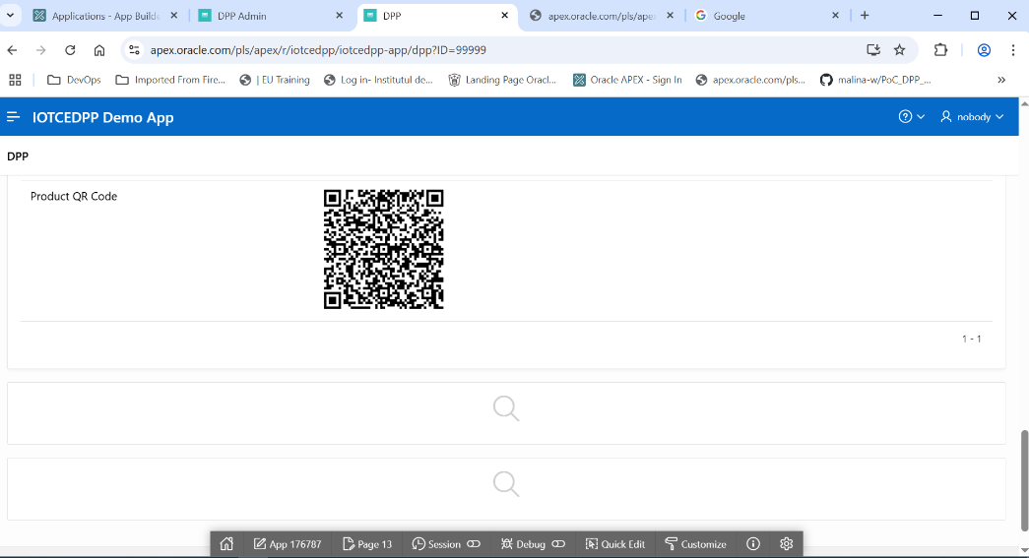
- Execution of the “DPP IoT Digital Twin Device Simulator” collection with five iterations;
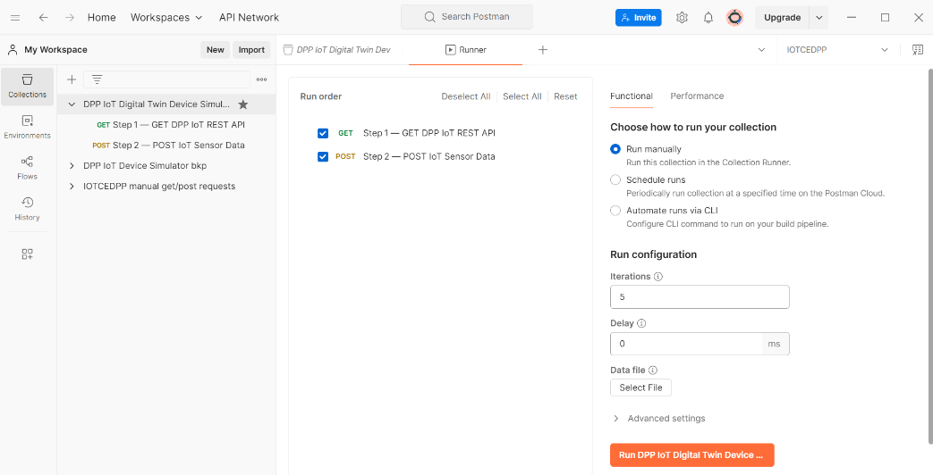
- Test results.
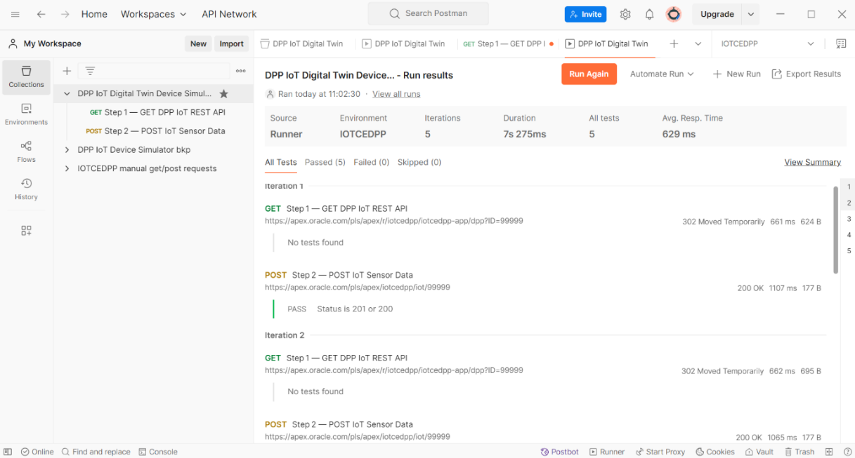
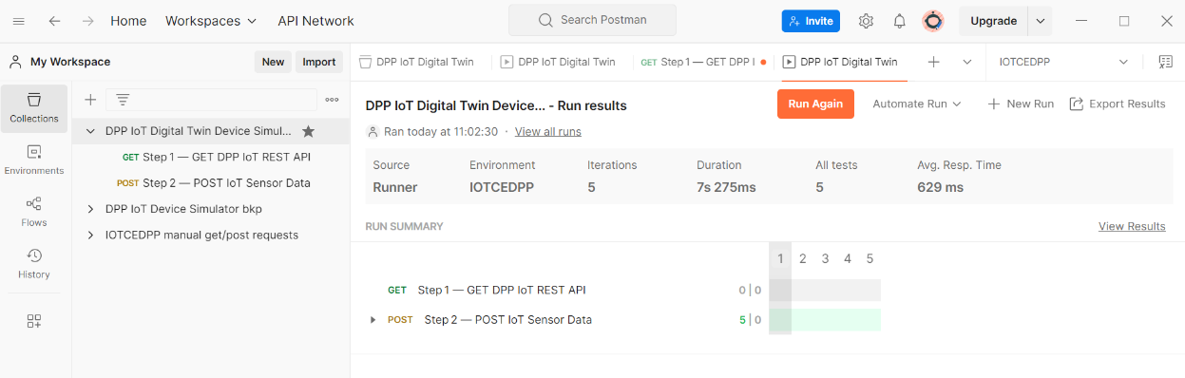
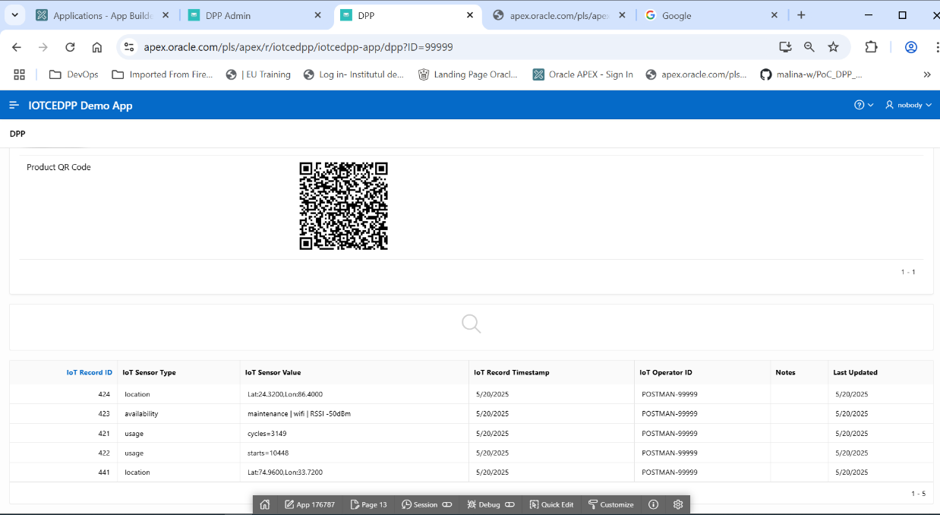
Finally, the same test collection can also be executed through Postman Flow, enabling a fully visual orchestration of the testing scenario.
